1. Artificial intelligence -> works like Human brain, but the brain is not made up of maths and work like prediction.i.e artificial brain.

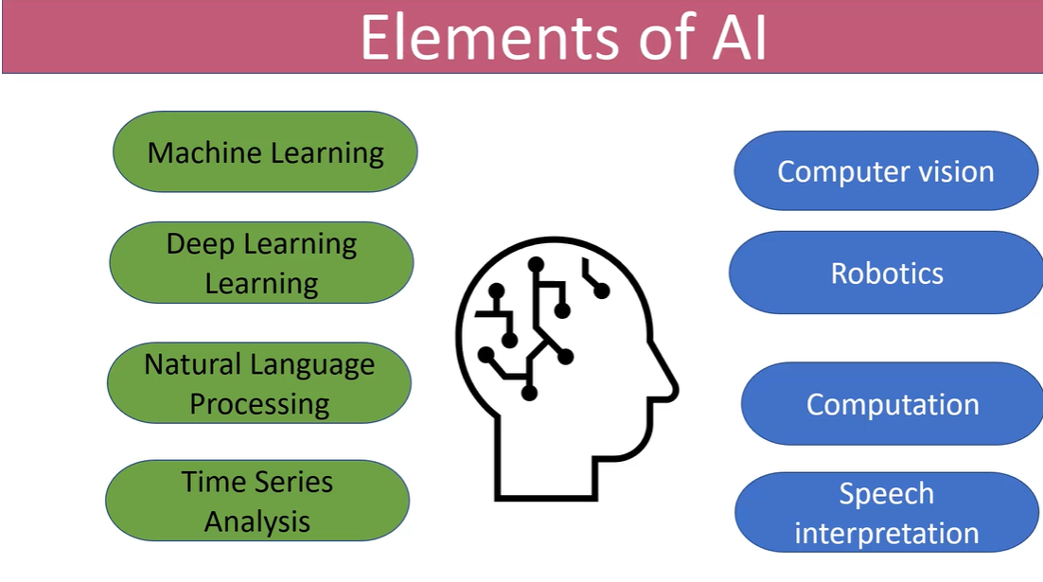

1. Human intelligence comparision with artificial intelligence

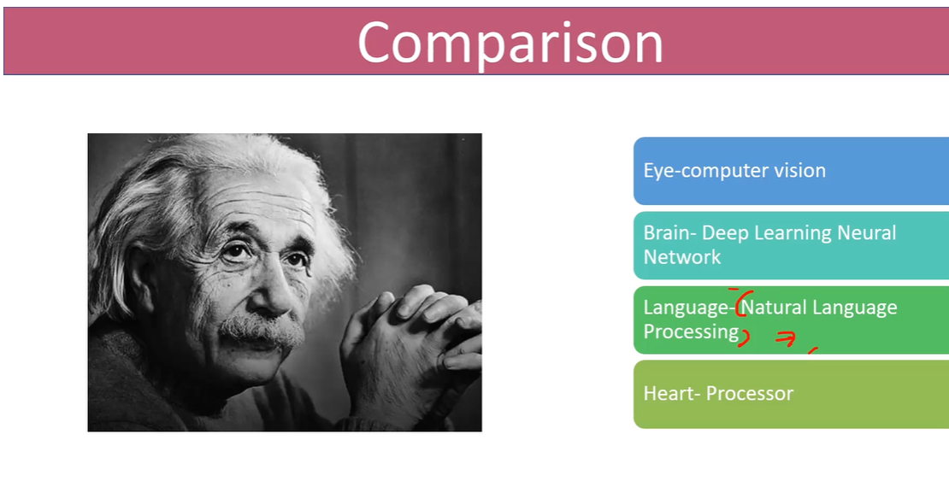

1. Core concept

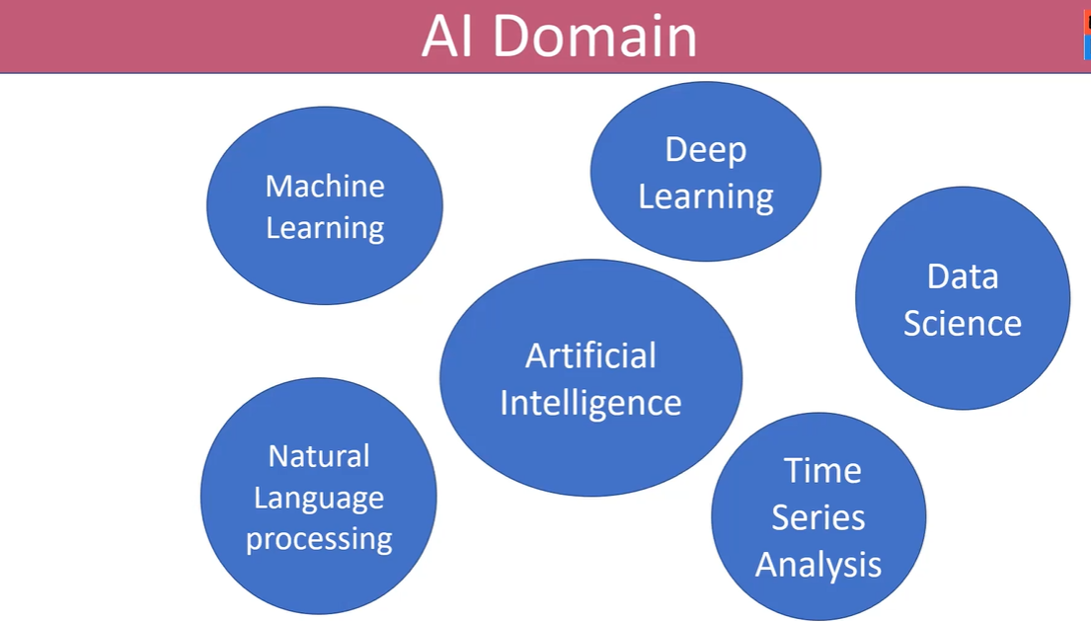

1. All under prediction except data science. Somehow analysis is depending on previous company profit and managing comparison.

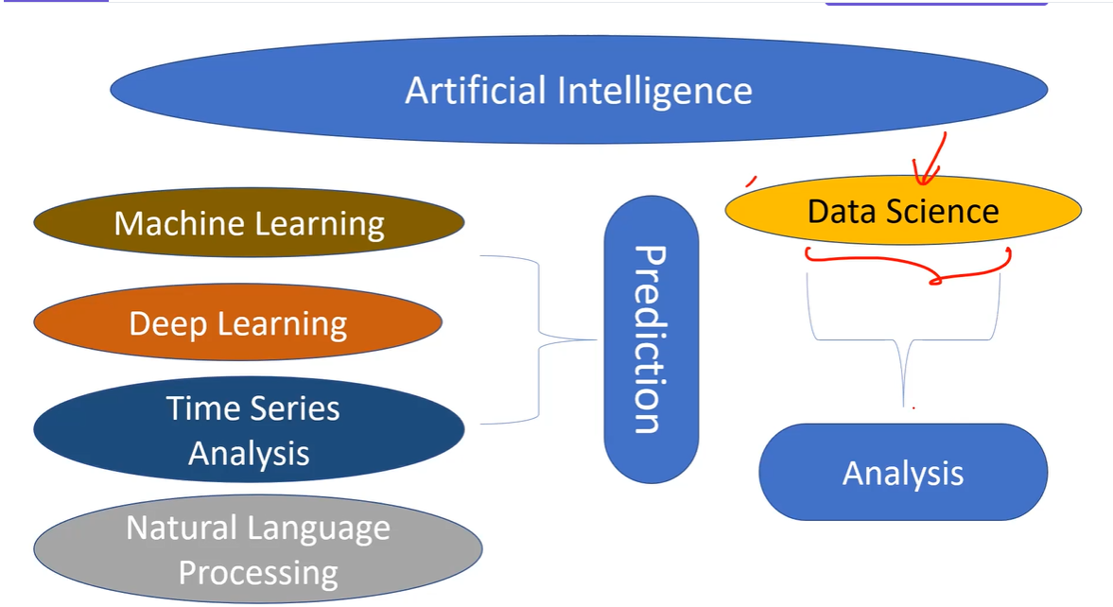

1. Domain selection based on the requirement.

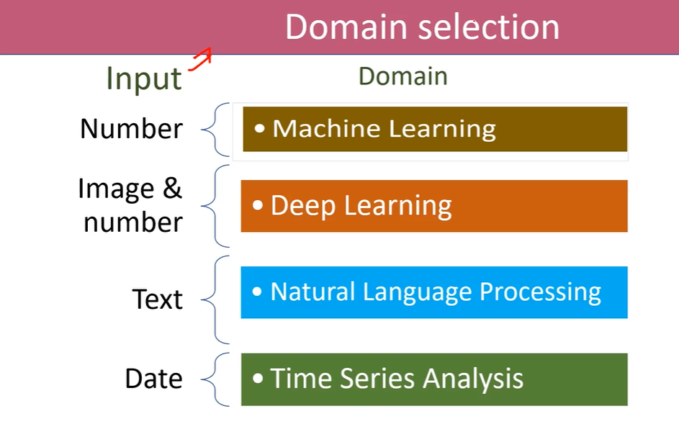

1. Prediction -> Input -> {DATA SET}
2. Machine Learning -> Numbers

Deep learning ->Images input as data set

Natural Language ->Text (Boolean) -> True/False Eg:Feedback -> Positive/negative

Time Series Analysis -> next year monsoon, Latituted.

1. Data Science -> {Statistics}

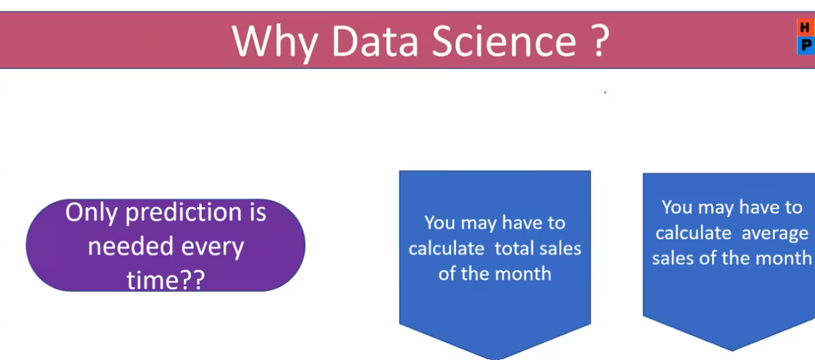

1. Maths -> calculator

Python acts as calculator, so we use Phython in AI

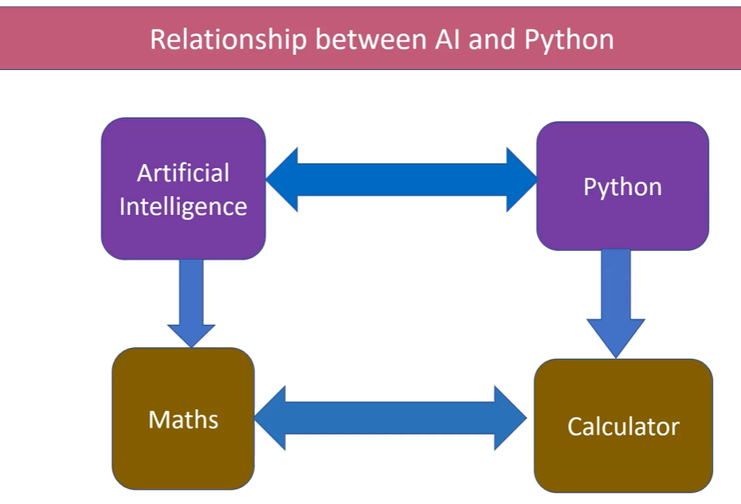

1. Phython

Eg: browser -> opera, firefox, google -> Appstore

Phython -> jupyter, spyder -> Anaconda

Jupyter, spyder -> IDE (integerated development environment)

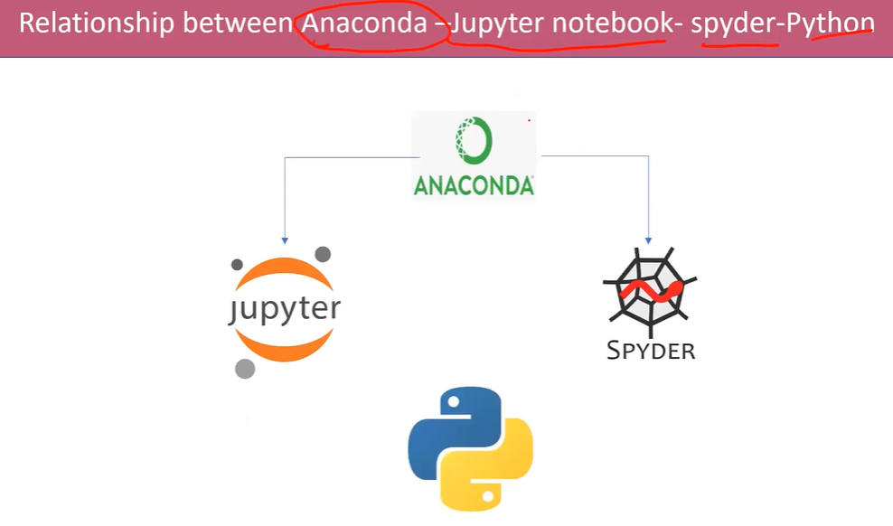

1. Tools:

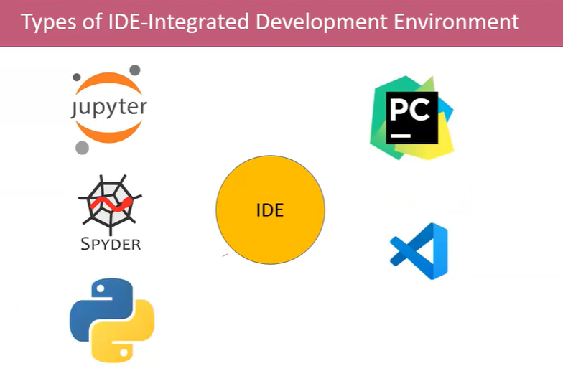

1. Python Programming Language:

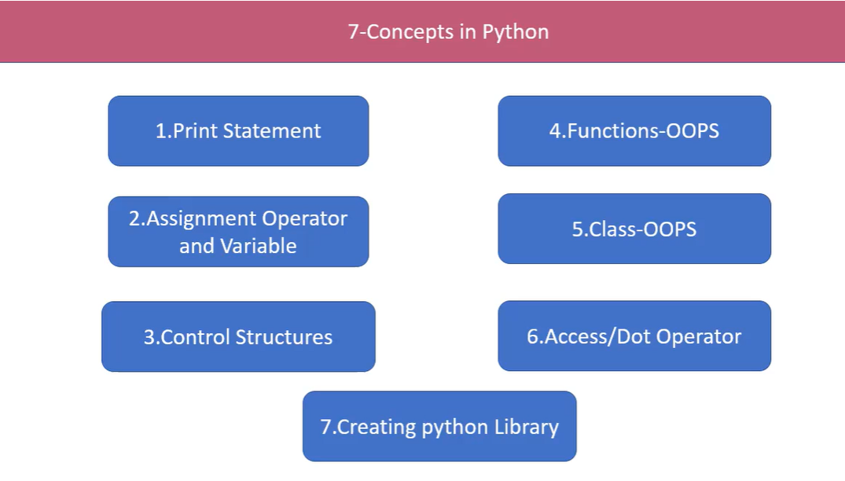

1. Print Statement:

print() -> print(“Rathiga”) -> O/P -> Rathiga

1. Variable and assignment:

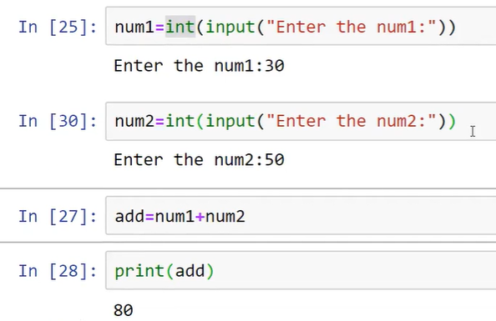

Initialize the variable -> num 1 , num 2

Datatype-> int

Runtime input get -> input

“ “ -> string

1. 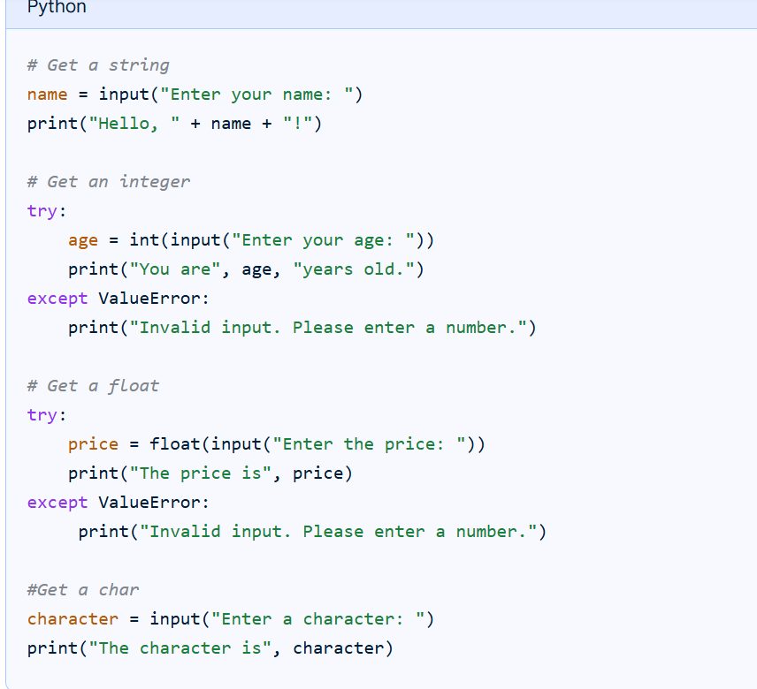
2. Control_Statement:

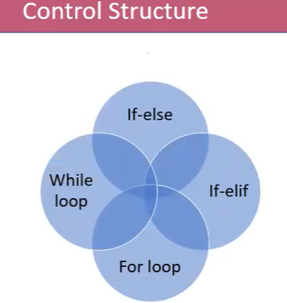

1. If statement:

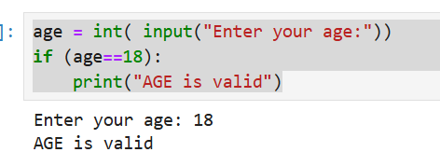

1. If else statement:

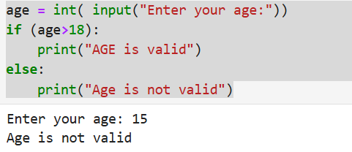

1. If-elif

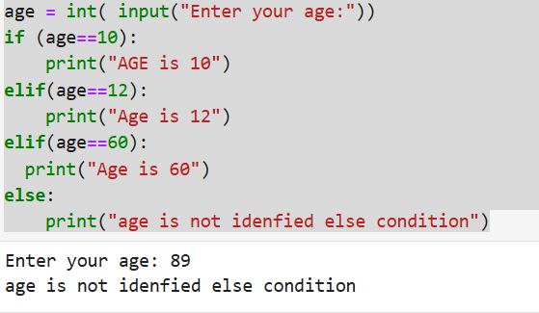

1. For Loop: (Multiple input set under one condition)

**Example 1:**

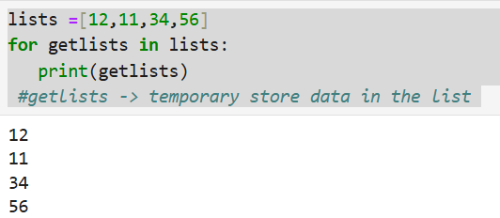

**Example 2:**

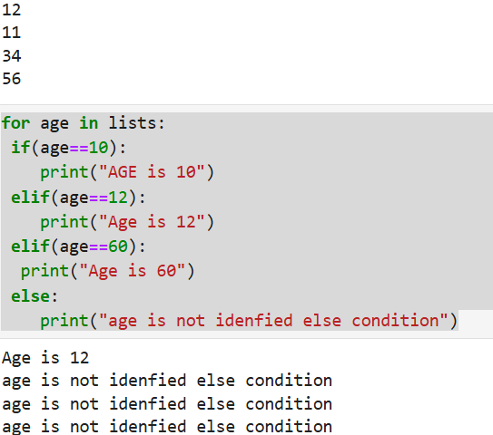

1. Range (num1,num2) -> Start, Stop

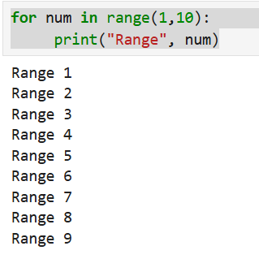

Range(num1.num2,num3) -> Start, stop, Step

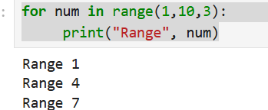

1. OOPS – Function

**Syntax:**

def functionname():

--------

-------

Return

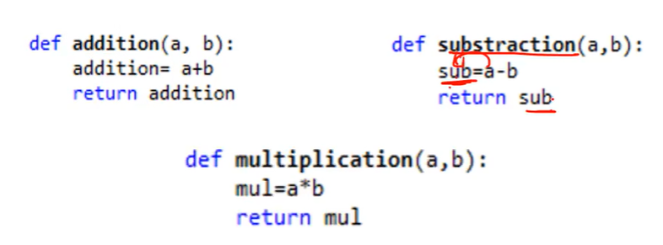

Example:

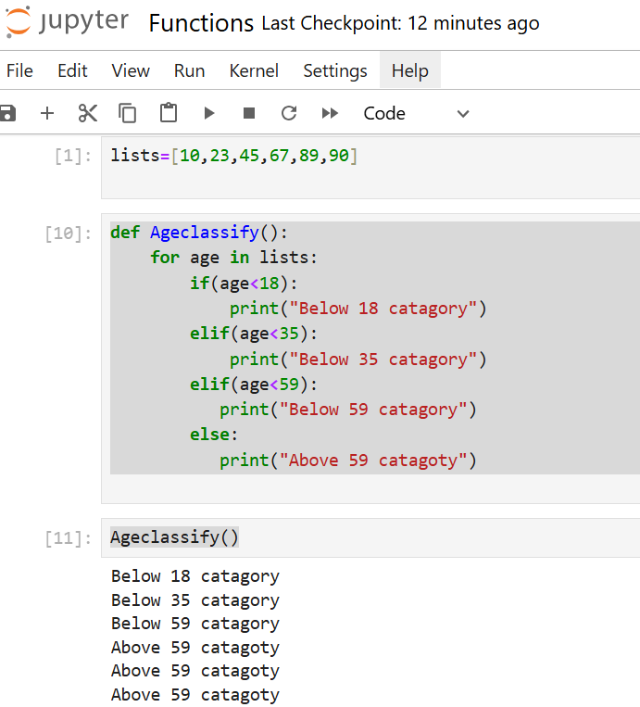

Example with return statement:

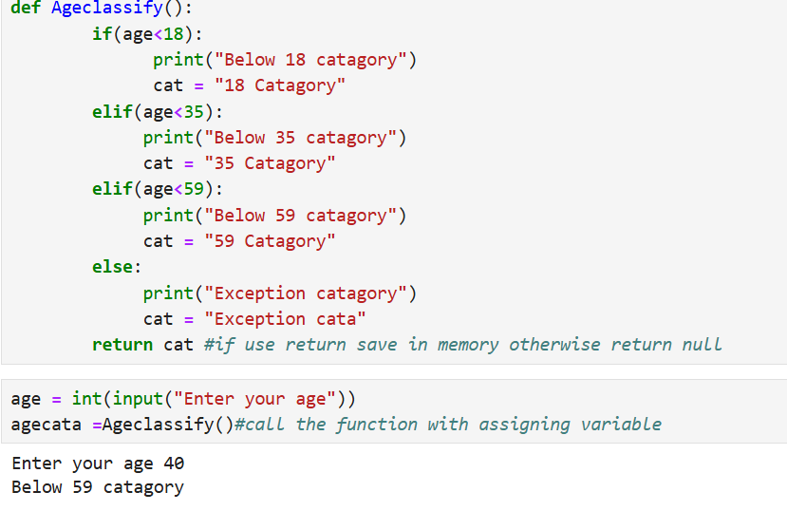

**Example: With arguments:**

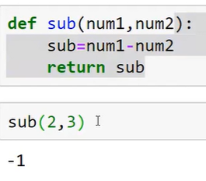

1. Class -> Group of Function

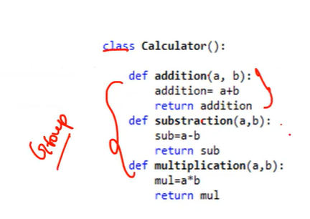

**Example 1:**

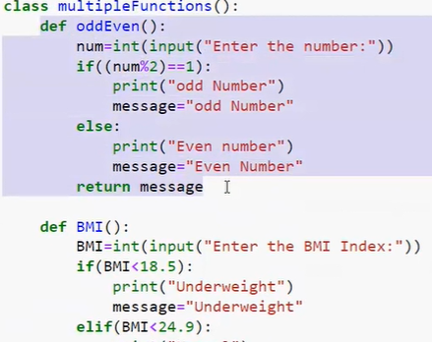

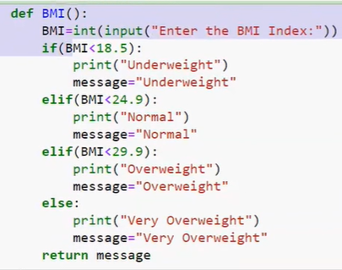

 - > Call the function (Classname.Functionname())

**Output:**

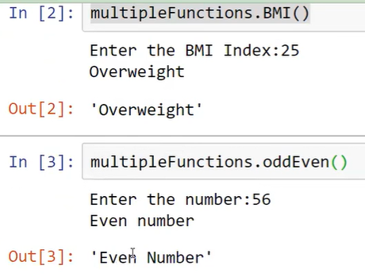

**Example 2:**

Want to use the class in another project/File -> need to import

**Syntax:** from filename import classname

